Phi Sigma Rho
3.9
3.7
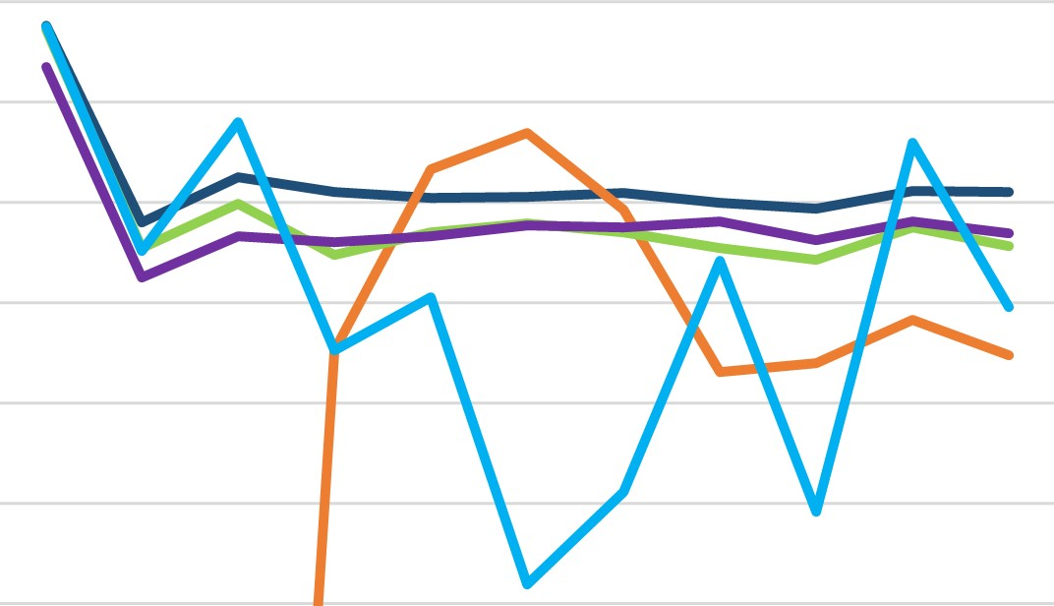
3.5
All Female

3.3-....—AII GIC
All Greek 3.1
All Student
2.9
Sigma R ho
2.7
2.5
S20 F 20 S21 F 21 S22 F 22 S23 F 23 S24 F 24 S25

